Meeting Location: Colorado Mountain College
Meeting Purpose: Monthly Board Meeting
Date: September 20, 2017

Present: Ali Kelkenberg, Mellanee Montgomery, Erica Schneider, Barb Waters, Linda Giordano (by phone), Cherie Chavis

President’s Update (Ali)
- New board member, Erica Schneider, Treasurer
- Bylaws Update – Michelle is working on it
- Volunteer Leader Summit in DC, November 16th – 18th (Ali and Michelle will attend)
- January Board Retreat – set date at October board meeting

Financial Update (Ali)
- Fund Balance with US Bank is $3,348.84 and PayPal is $249.99 for a total of $3,598.83.
- Unpaid Invoices: The Four Seasons $875 check for boot camp is on the way.

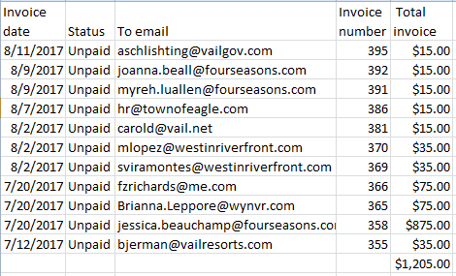

Membership Update (Karyne)
- 88 active with 5 pending
- A few will expire at the end of the month

Programs Update (Linda):
- Leadership & Engagement for HR Professionals: postponing this to 2018
- September 27th – 29th – COSHRM State Conference in Keystone, Ali will send a blast to ask for help
- October 26th – Being a Positive Leader: Small Shifts that Lead to Big Results - Amy Packer; 3pm to 5pm at CMC
- December – E-Town – set date at October board meeting

Marketing and Communications Update (Ali)
- Ali will send a blast asking any attendees if they can help
- Promote Leadership & Engagement Program – goal is 30 participants
- Met with Travis Coggin from Vail Valley Young Professionals Association. They will blast our events to their membership. We will do a reciprocal blast for their events.
- Interested in Vail Valley Business Women (VVBW) partnership

Certification Update (Cherie):
- Bootcamp has 9 participants
- Participant feedback has been provided to Cherie
- Cherie will buy a gift card for Lance
- We will provide a clean HCHRA logo to Lance for certificates of completion

SHRM Foundation and Diversity Update (Candie)

Legislative Affairs Update (Jessica):

College Relations and Workforce Readiness Updates (Mellanee)

Dates for upcoming Job Fairs:
  - Work in Vail - Oct 16, 4-7pm, Vail Library - must have business or job opening in Vail
  - Winter Job Fair - Nov 2nd has been cancelled
Other Discussion:
  - Planning for COSHRM Conference in Keystone – Who will be at the conference?
  - Notes from COSHRM Quarterly Meeting:
    - Normal booth space is sold out
    - Boards must staff tables at all breaks and table staff must be registered for the conference
    - Board members should be role models by spending as much time as possible in the exhibit hall.
    - Don’t forget your 80s ski gear – theme for party
    - 12.5 total credit hours if you attend the whole conference and attend all of the credited slots
    - COSHRM needs another 70 registrants – chapters can help by marketing with social media
    - Calla Pott and Angelo Fernandez had a lunch meeting with each chapter to discuss the chapter tables and swag (see handout of email)
  - Coordinate a meeting location for everyone from HCHRA so the group can go to dinner or drinks together. Not funded by HCHRA…everyone would pay their own way
  - Swag for booth, HCHRA materials to be displayed, membership drive, staffing booth (schedule)

  - Board Positions – current update/nominations
  - 2018 Communications – need a volunteer
  - 2018 Secretary – need a volunteer
  - 2018 Programs – Amy Packer
  - 2018 Community Outreach – Linda Giordano
  - In late November, Michelle will send slate of board member names and positions out to membership for vote via Survey Monkey (CLIF Report is due to SHRM at the beginning of December)

- Board Positions – current update/nominations
  - Consider virtual meetings if it makes it easier to attend

