Dave Dixon, Esq.
Staff Attorney, MSEC

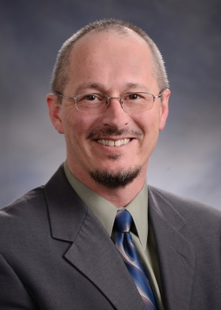
EDUCATION:
Dave earned his B.A. in economics from the University of Washington at Seattle, where he earned an invitation to join the Omicron Delta Epsilon National Economics Society and was recognized by Golden Key International Honour Society as the University’s Outstanding Junior. He graduated from Duke University School of Law with honors.

WORK HISTORY:
A manager for years before law school, Mr. Dixon helps employers solve problems in all settings.
Mr. Dixon has focused his entire legal career exclusively on advising and representing employers
in the full spectrum of labor & employment issues, including wage & hour class actions, individual wage claims, harassment, discrimination, disability accommodation, retaliation, unfair competition, trade secrets, and other matters. He is admitted to practice in California, Colorado, Nevada and Wisconsin.
Mr. Dixon strongly believes in reducing risk through proactive management education. He has provided numerous presentations on topics including harassment prevention, wrongful discharge, ADA/FMLA/WC overlap, wage & hour compliance, workplace privacy, workplace violence, reductions in force, and more. In the early 2000’s, he co-authored a California-specific HR law treatise for his students at CSU - Sacramento. At the request of the California State Council of SHRM, he later co-authored the 1st and 2nd editions of the SHRM California Learning SystemTM and helped coordinate annual HR participation in legislative affairs by all California SHRM affiliates. In 2010, Dave returned to his home town of Fort Collins, where he is a fifth generation resident.

SPECIAL ASSOCIATIONS:
Northern Colorado Human Resource Association (NCHRA), Legislative Director, 2011-present
Kern County Society for Human Resource Management (KCSHRM), President, 2010, Legislative Director 2005-2008
Eastern District of California Lawyer Representative to Ninth Circuit Judicial Conference, 2008-2010
San Joaquin Valley Chapter Federal Bar Association, Board of Directors, 2007-2010
Kern County Bar Association (KCBA), Vice-President, 2010, Chair of Employment Committee, 2006-2010
KCBA – Young Lawyers Section, Inaugural Chair, 2004-2006, Immediate Past-Chair, 2007
Sacramento Area Human Resources Association (SAHRA), Legal & Legislative Group, 2002-2005
Duke Bar Association, Vice-President, 1999, Class Representative, 1998
Membership in multiple state bar associations and related local bar associations

